**DEVELOPMENT OF PATH FOLLOWING CONTROLLER FOR CONTROLLING THE TWO LINK MANIPULATOR**

*A Major Project Report*

*Submitted in partial fulfilment of*

*the requirement for the B.Tech.*

*Under Biju Patnaik University of Technology, Rourkela.*

**PROJECTID:9508**

*Submitted by*

**Saradashree Patra Roll # ELE201311219**

**Swapna Rani Kuanr Roll # ELE201311074**



*2016 - 2017*

*Under the guidance of*

**Dr. BASANT KUMAR SAHU**

**NATIONAL INSTITUTE OF SCIENCE & TECHNOLOGY**

**Palur Hills, Berhampur- 761008, Odisha, India**

# ACKNOWLEDGEMENT

We would like to take this opportunity to thanks all those individuals whose invaluable contribution in a direct or indirect manner has gone into the making of this project report is a tremendous learning experience for us.

We give our sincere thanks to **Dr. Basant Kumar Sahu, Project Advisor** for giving us the opportunity and motivating us to complete the project within stipulated period of time and providing a helping environment.

We give our sincere thanks to **Mr Sandipan Mallick, Project Coordinator**, for helping us throughout our project and encouraging us to complete this project.

We acknowledge with immense pleasure the sustained interest, encouraging attitude and constant inspiration rendered by **Prof. Sangram Mudali** (Director) & **Prof. Geetika Mudali** (Placement Director)N.I.S.T. Their continued drive for better quality in everything that happens at N.I.S.T. and selfless inspiration has always helped us to move ahead.

**Saradashree Patra**

**Swapna Rani Kuanr**

# ABSTRACT

Due to the advantage like high speed, accuracy and repeatability, robot manipulators have become major component of manufacturing industries and even now a days they become part of routine life. Two link robot manipulator is a very basic classical and simple example of robot followed in understanding of basic fundamentals of robotic manipulator. The equation of motion for two link robot is a nonlinear differential equation. As the closed form solutions are not available we used numerical solution. Because of these uncertainties and nonlinear behavior, it's a challenging task to control the motion of robot manipulator at accurate position. The literature survey and simulation work in the two link robotic manipulator (TLRM) has completed. Here we focused mainly on control of robot manipulator to get the desired position using PD controller. After deriving the equation of motion, control simulation is represented using MATLAB.

# TABLE OF CONTENTS

ACKNOWLEDGEMENT i

ABSTRACT ii

TABLE OF CONTENTS iii

LIST OF FIGURES v

CHAPTER 1 1

INTRODUCTION 1

1.1 LITERATURE SURVEY 2

1.2 APPLICATION 3

1.3 MOTIVATION 3

1.4 OBJECTIVE 3

1.5 PROBLEM FORMULATION 4

CHAPTER 2 5

HISTORY OF CONTROLLERS 5

2.1 USES OF CONTROLLERS 5

2.2 TYPES OF CONTROLLERS 6

2.2.1 CONTINUOUS CONTROLLERS: 6

2.2.1.1 PROPORTIONAL CONTROLLERS 6

2.2.1.2 INTEGRAL CONTROLLERS 8

2.2.1.3 DERIVATIVE CONTROLLERS 10

PROPORTIONAL AND INTEGRAL CONTROLLER 11

PROPORTIONAL AND DERIVATIVE CONTROLLER 12

PID CONTROL SYSTEM 13

CHAPTER 3 15

3.1 KINEMATICS 15

3.2 DYNAMICS 17

CHAPTER 4 20

4.1 RESULT 20

CHAPTER 5 27

5.1 ADVANTAGES OF ROBOTIC MANIPULATOR 27

5.2 DISADVANTAGES OF ROBOTIC MANIPULATOR 27

CHAPTER 6 28

FUTURE WORK 28

CHAPTER 7 29

CONCLUSIONS 29

REFERENCES 30

# LIST OF FIGURES

FIGURE 1:- PROPORTIONAL CONTROL ACTION 7

FIGURE 2:- INTEGRAL CONTROL ACTION 9

FIGURE 3:-PROPORTIONAL PLUS INTEGRAL CONTROL ACTION 12

FIGURE 4:-PROPORTIONAL PLUS DERIVATIVE CONTROL ACTION 13

FIGURE 5:- TWO DEGREE OF FREEDOM ROBOT MANIPULATOR 16

FIGURE 6:-PD CONTROL ACTION 19

FIGURE 7:-TWO LINK PLANAR ROBOT 20

FIGURE 8:-VELOCITIES FOR TWO LINK PLANAR ROBOT 21

FIGURE 9:-PHASE PLOT 22

FIGURE 10:-DESIRED DISPLACEMENT 23

FIGURE 11:-REAL DISPLACEMENT 24

FIGURE 12:-TORQUE INPUTS 25

FIGURE 13:-TRACKING ERROR 26

# CHAPTER 1

# INTRODUCTION

Robotics is a complex field involving many diverse disciplines, such as physics, properties of materials, statics and dynamics, electronics, control theory, vision, signal processing, computer programming, and manufacturing. In this project our main interest is control of robot manipulators. The purpose of this project is to study the dynamical equations needed for the study of robot control. When studying advanced techniques for robot control, planning, sensors, and human interfacing, it is important to be aware of the systems that are commercially available. This allows one to develop new technology in the context of existing technology, which allows one to implement the new techniques on existing robotic systems. The rising popularity of robotic work cells has taken emphasis away from hardware design and placed new emphasis on innovative software techniques and architectures that include planning, coordination, and control (PC&C) functions. A great deal of research into robot controllers has been required to give robots the flexibility, precision, and functionality needed in modern flexible work cells. Robots are highly reliable, dependable and technologically advanced factory equipment. The basic architecture of most commercial robots is fundamentally the same, and consists of digital servo controlled electrical motor drives on serial-link kinematic machines, usually with no more than six axes (degrees of freedom). All are supplied with a proprietary controller. Virtually all robot applications require significant design and implementation effort by engineers and technicians. What makes each robot unique in how the components are put together to achieve performance that yields a competitive product. The most important considerations in the application of an industrial robot center on two issues: manipulation and integration.

It is well established that robotic manipulators are highly dynamically coupled, time-varying, and highly nonlinear systems that are extensively used in industrial applications. The robotic manipulators are generally subjected to both structured and unstructured uncertainties which make the accurate position control of the robotic arms a challenging task. The end effectors of the robotic manipulators are to follow some desired trajectories as close as possible. Therefore, trajectory tracking problem is the most significant and fundamental task in control of robotic manipulators. With the use of the robots in critical applications like medical and other sensitive areas, the precise control of the robot arms has become an essential requirement. Motivated by such control requirements, for practical and complex control problem of robotic manipulators, in the past decades, many research contributions have been reported on robotic control schemes such as such as proportional-integration-derivative (PID) control ,PD control, PI control, feed-forward compensation control, adaptive control , variable structure control , computed torque control. The conventional control techniques are inadequate under large uncertainty and/or unpredictable variations in system parameters and structures. Most conventional control techniques require a precise mathematical model, which is not always possible but tuning of the controller highly required for getting the desired result. In this paper, a PD control scheme is developed and implemented for trajectory tracking problem of two-link robotic manipulator.

To summarize: we will deal with unconstrained motionof the manipulator as it follows some trajectory as well as its interaction with parts that mechanically constrain its motion. Both aspects of manipulator operation are of importance if it is to be used to assemble or disassemble artifacts.

# 1.1 Literature Survey

Controllers have their origins in 19th century speed [governor](https://en.wikipedia.org/wiki/Governor_(device)) design. The theoretical basis for the operation of governors was first described by [James Clerk Maxwell](https://en.wikipedia.org/wiki/James_Clerk_Maxwell) in 1868 in his seminar paper 'On Governors', but it was not until 1922 that controllers were first developed using a theoretical analysis, by [Russian American](https://en.wikipedia.org/wiki/Russian_American) engineer [Nicolas Minorsky](https://en.wikipedia.org/wiki/Nicolas_Minorsky) ([Minorsky 1922](https://en.wikipedia.org/wiki/PID_controller" \l "CITEREFMinorsky1922)) for automatic ship steering. Minorsky was designing automatic steering systems for the US Navy and based his analysis on observations of a [helmsman](https://en.wikipedia.org/wiki/Helmsman), noting the helmsman steered the ship based not only on the current course error, but also on past error, as well as the current rate of change; this was then given a mathematical treatment by Minorsky. His goal was stability, not general control, which simplified the problem significantly. While proportional control provides stability against small disturbances, it was insufficient for dealing with a steady disturbance, notably a stiff gale (due to [steady-state error](https://en.wikipedia.org/wiki/PID_controller#Steady-state_error)), which required adding the integral term. Finally, the derivative term was added to improve stability and control. Trials were carried out on the [USS *New Mexico*](https://en.wikipedia.org/wiki/USS_New_Mexico_(BB-40)), with the controller controlling the [*angular velocity*](https://en.wikipedia.org/wiki/Angular_velocity) (not angle) of the rudder.

# 1.2 Application

* Robots have been used at the workstation level to perform operations such as assembly, drilling, surface finishing, welding, palletizing, and so on.

# 1.3 Motivation

* By referring a number of research articles and books we came to know that the path following controller of two link robotic manipulator (TLRM) is an important and popular research topic in recent era.
* Hence we are motivated to develop a path following controller for two link robotic manipulator.

# 1.4 Objective

# The objective is to develop the path following controller which will be able to make a robot follow the reference path. We can define the contour error, which is the error that enables us to measure the distance from the reference path to the configuration of the robot.

# 1.5 Problem formulation

Starting from any arbitrary point, after some time the desired path as it match to the actual path i.e. enter between actual path and desired path will be zero.

Mathematically,

$\lim_{t→∞}{(n_{r}-n})$ =0

Where $n_{r=}$ Position vector of the desired path

n=Position vector after actual path of the manipulator

# CHAPTER 2

# HISTORY OF CONTROLLERS

A controller is one which compares controlled values with the desired values and has a function to correct the deviation produced.

• Reads the measured Process Variable

– What you got

• Knows what you want

– Set point

• Compares what you got (PV) to what you want (SP)

• Makes a decision based on the comparison

– Hold steady

– Increase

– Decrease

• Holds or changes its output

## 2.1 Uses of Controllers

The important uses of controllers in the theory of control system are:

* Controllers improve steady state accuracy by decreasing the steady state errors.
* As the steady state accuracy improves, the stability also improves.
* They also help in reducing the offsets produced in the system.
* Maximum overshoot of the system can be controlled using these controllers.
* They also help in reducing the noise signals produced in the system.
* Slow response of the over damped system can be made faster with the help of these controllers.

## 2.2 Types of Controllers

There are mainly two types of controllers:

1. Continuous Controllers
2. Discontinuous Controllers

### 2.2.1 Continuous Controllers:

 The main feature of continuous controllers is that the controlled variable (also known as the manipulated variable) can have any value within the range of controller’s output. Now in the continuous controller’s theory, there are three basic modes on which the whole control action takes place. We will use the combination of these modes in order to have a desired and accurate output. The basic modes are:

1. Proportional controllers.
2. Integral controllers.
3. Derivative controllers.

Combination of these three modes can be written as:

1. Proportional and derivative controllers.
2. Proportional and integral controllers.
3. PID Control System

### 2.2.1.1 Proportional Controllers

The proportional term produces an output value that is proportional to the current error value. The proportional response can be adjusted by multiplying the error by a constant *K*p, called the proportional gain constant.We cannot use **types of controllers** at anywhere, with each

type controller, there are certain conditions that must be fulfilled. With **proportional controllers** there are two conditions and these are written below:

1. Deviation should not be large, it means there should be less deviation between the input and output.
2. Deviation should not be sudden.

As we know in proportional controller output is directly proportional to error signal, writing this mathematically we have,



Removing the sign of proportionality we have,



Where, Kp is proportional constant also known as controller gain. It is recommended that Kp should be kept greater than unity. If the value of Kp is greater than unity, then it will amplify the error signal and thus the amplified error signal can be detected easily. A high proportional gain results in a large change in the output for a given change in the error. If the proportional gain is too high, the system can become unstable . In contrast, a small gain results in a small output response to a large input error, and a less responsive or less sensitive controller. If the proportional gain is too low, the control action may be too small when responding to system disturbances. Tuning theory and industrial practice indicate that the proportional term should contribute the bulk of the output change.

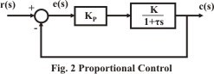

Figure 1:- PROPORTIONAL CONTROL ACTION

**Steady-state error**

Because a non-zero error is required to drive it, a proportional controller generally operates with a so-called *steady-state error.* Steady-state error (SSE) is proportional to the process gain and inversely proportional to proportional gain. SSE may be mitigated by adding a compensation bias term to the set point or output, or corrected dynamically by adding an integral term.

**Advantages of Proportional Controller**

Some advantages of proportional controller.

1. Proportional controller helps in reducing the steady state error, thus makes the system more stable.
2. Slow response of the over damped system can be made faster with the help of these controllers.

**Disadvantages of Proportional Controller**

Some disadvantages of these controllers are written as follows:

1. Due to presence of these controllers we some offsets in the system.
2. Proportional controllers also increase the maximum overshoot of the system.

### 2.2.1.2 Integral Controllers

### As the name suggests in integral controllers the output (also called the actuating signal) is directly proportional to the integral of the error signal. As we know in an integral controller output is directly proportional to the integration of the error signal. The contribution from the integral term is proportional to both the magnitude of the error and the duration of the error. The integral in a PID controller is the sum of the instantaneous error over time and gives the accumulated offset that should have been corrected previously. The accumulated error is then multiplied by the integral gain (*K*i) and added to the controller output.

The integral term is given by

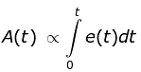

Removing the sign of proportionality we have,

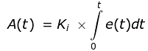

Where Ki is integral constant also known as controller gain. Integral controller is also known as reset controller.

{\displaystyle I_{\text{out}}=K_{\text{i}}\int _{0}^{t}e(\tau )\,d\tau }The integral term accelerates the movement of the process towards set point and eliminates the residual steady-state error that occurs with a pure proportional controller. However, since the integral term responds to accumulated errors from the past, it can cause the present value to [overshoot](https://en.wikipedia.org/wiki/Overshoot_(signal)) the set point value.

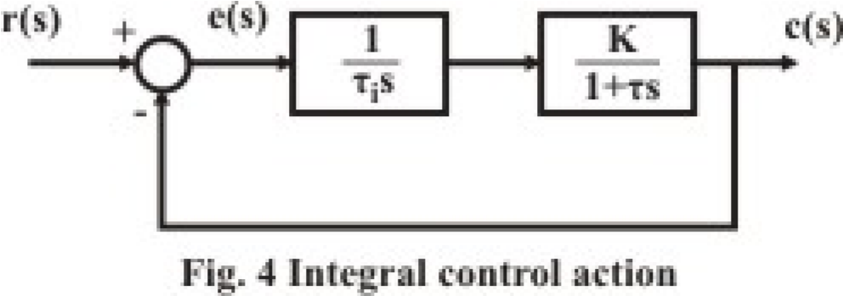

Figure 2:- INTEGRAL CONTROL ACTION

**Advantages of Integral Controller**

1. Due to their unique ability they can return the controlled variable back to the exact set point following a disturbance that’s why these are known as reset controllers.

**Disadvantages of Integral Controller**

It tends to make the system unstable because it responds slowly towards the produced.

### 2.2.1.3 Derivative Controllers

We never use **derivative controllers** alone. It should be used in combinations with other modes of controllers because of its few disadvantages which are written below:

1. It never improves the steady state error.
2. It produces saturation effects and also amplifies the noise signals produced in the system.

Now, as the name suggests in a derivative controller the output (also called the actuating signal) is directly proportional to the derivative of the error signal. The derivative of the process error is calculated by determining the slope of the error over time and multiplying this rate of change by the derivative gain *K*d. The magnitude of the contribution of the derivative term to the overall control action is termed the derivative gain, *K*d.

The derivative term is given by



Removing the sign of proportionality we have,



Where, Kd is proportional constant also known as controller gain. Derivative controller is also known as rate controller.

Derivative action predicts system behavior and thus improves settling time and stability of the system. An ideal derivative is not casual, so that implementations of PID controllers include an additional low-pass filtering for the derivative term to limit the high-frequency gain and noise. Derivative action is seldom used in practice though – by one estimate in only 25% of deployed controller – because of its variable impact on system stability in real-world application.

**Advantages of Derivative Controller**

The major advantage of derivative controller is that it improves the transient response of the system.

### Proportional and Integral Controller

As the name suggests it is a combination of proportional and an integral controller the output (also called the actuating signal) is equal to the summation of proportional and integral of the error signal. In a proportional and integral controller output is directly proportional to the summation of proportional of error and integration of the error signal, writing this mathematically we have,

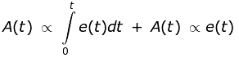

Removing the sign of proportionality we have,

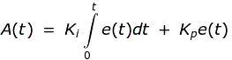

Where, Ki and kp proportional constant and integral constant respectively.

Advantages and disadvantages are the combinations of the advantages and disadvantages of proportional and integral controllers.

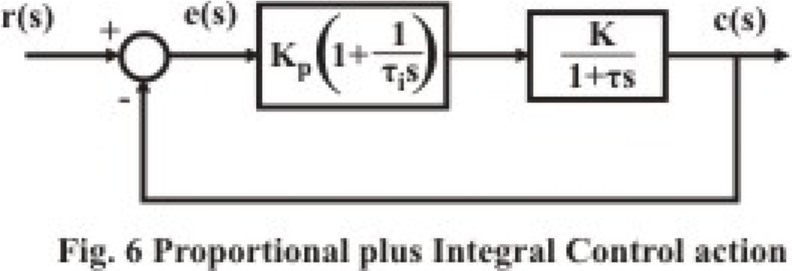

Figure 3:-PROPORTIONAL PLUS INTEGRAL CONTROL ACTION

### Proportional and Derivative Controller

It is a combination of proportional and a derivative controller the output (also called the actuating signal) is equals to the summation of proportional and derivative of the error signal. It is effective for systems having large number of time constants. It results in a more rapid response and less offset than is possible by pure proportional control. But one must be careful while using derivative action in control of very fast processes, or if the measurement is noisy (e.g. flow measurement). The aim of using P-D controller is to increase the stability of the system by improving control since it has an ability to predict the future error of the system response. In order to avoid effects of the sudden change in the value of the error signal, the derivative is taken from the output response of the system variable instead of the error signal. Therefore, D mode is designed to be proportional to the change of the output variable to prevent the sudden changes occurring in the control output resulting from sudden changes in the error signal. In addition D directly amplifies process noise therefore D-only control is not used.

As we know in a proportional and derivative controller output is directly proportional to summation of proportional of error and differentiation of the error signal, writing this mathematically we have,



Removing the sign of proportionality we have,



Where, Kd and kp proportional constant and derivative constant respectively. Advantages and disadvantages are the combinations of advantages and disadvantages of proportional and derivative controllers.

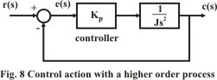

Figure 4:-PROPORTIONAL PLUS DERIVATIVE CONTROL ACTION

### PID control system

Once the model is obtained, the control simulation analysis is run based on PID controller. A proportional integral derivative controller (PID controller) is a generic control loop feedback mechanism (controller) that is widely used in Industrial control system. This is a type of feedback controller whose output ,a control variable (CV), is generally based on the error (e) between some user defined set point(SP) and some ,measured process variable(PV). The controller calculation (algorithm) involves three separate parameters, and is accordingly called there-term control: the proportional, integral and derivative values, denoted,,and . Each element of the PID controller refers to a particular action on the error.

* **Proportional:** error multiplied by a gain,. This is an adjustable amplifier. In many system  is responsible for process stability: too low and the PV can drift away: too high and PV can oscillate.
* **Integral:** the integral of error multiplied by a gain  is responsible for driving error to zero, but to set  too high is to invite oscillation or instability.
* **Derivative:** the rate of change of error multiplied by a gain ,  is responsible for system response :too high and the PV will oscillate too low and the PV will respond sluggishly

P-I-D controller has the optimum control dynamics including zero steady state error, fast response (short rise time), no oscillations and higher stability. The necessity of using a derivative gain component in addition to the PI controller is to eliminate the overshoot and the oscillations occurring in the output response of the system. One of the main advantages of the P-I-D controller is that it can be used with higher order processes including more than single energy storage.

# CHAPTER 3

### KINEMATICS AND DYNAMICS

## 3.1 KINEMATICS

In two dimensions one clearly needs two degrees of freedom to reach an arbitrary point within a given work space. Let us first study a simple two-link manipulator with rotational joints. Note that the geometry of the two-link device occurs as a sub problem in many of the more complicated manipulators. Given the two joint angles, let us calculate the position of the tip of the device.

Define vectors corresponding to the two links:

r1=l1 [cos (θ1), sin (θ2)]

r2=l2 [cos (θ1+θ2), sin (θ1+θ2)]

The position of the tip r can be found simply by vector addition.

x = 11 *cos (θ1) + l2*cos (θ1+θ2)

*y =*l1*sin (θ1) + l2*cos (θ1+θ2)

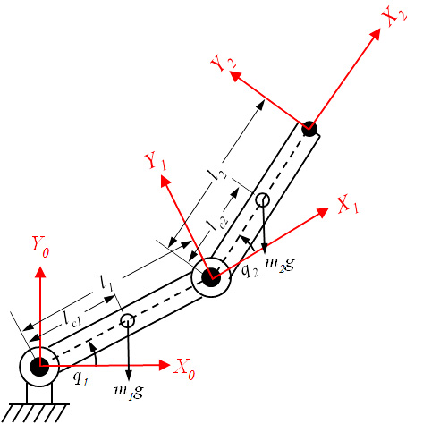

Figure 5:- Two Degree of Freedom Robot manipulator

Let us introduce the following notations:

qi - The joint angle of the joint i,

mi - The mass of link i,

li - The length of link i,

g - The gravitational acceleration.

This can be expanded into a slightly more useful form:

x = [l1 + l2 cos (θ2)] cos (θ1) – l2 sin (θ2) sin (θ1)

y = [l1 + 12 cos (θ2)] sin (θ1) – l2 sin (θ2) cos (θ1)

## 3.2 DYNAMICS

The dynamics of a robot arm is highly non-linear. The acceleration, velocity and angle of a single joint affect other joints. Moreover, other external forces including Coriolis force, centrifugal force, gravity, friction etc. are present, and they can influence the states of a robot. The states of a robot have an effect on themselves a well. In order to control the arms, the torque at each joint must be calculated every moment. But with the increase of degree of freedom, calculating time also increases. Moreover the unknown external forces also can be applied to the robot.

What angular accelerations of the links will be produced?

Knowing the relation between these two quantities will allow us to control the motions of the device as it follows some desired trajectory. We could proceed along lines similar to the ones followed when we studied statics, simply adding Newton's law.

F = ma

or

T = $I{α}$

Where **F** is a force, **m** mass and **a** linear acceleration. Similarly **T** is a torque, **I** moment of inertia and $α$ angular acceleration. The quantities involved would have to be expressed relative to some Cartesian coordinate system. We would be faced with large sets of nonlinear equations, since the mechanical constraints introduced by the linkage would have to be explicitly included and the coordinates of each joint expressed. In general, this method becomes quite unwieldy for manipulators with more than a few links. The more general form of Newton's law indicates a better approach:

Fi = d/dt (mvi)

Where **Fi** is a component of the force and **mvi** is a component of the linear momentum. It is possible to develop a similar equation in a generalized coordinate system that does not have to be Cartesian. It is natural to choose the joint angles as the generalized coordinates. These provide a compact description of the arm configuration and the mechanical constraints are implicitly taken care of. It can be shown that:

Qi *=* d/dt pi - ∂L/∂qi

Where **Qi** is a generalized force, **pi** generalized momentum and **qi** one of the generalized coordinates. There is one such equation for each degree of freedom. **Qi** will be a force for an extensional joint, and a torque for a rotational joint. In both cases, **Qiqi** has the dimensions of work.

**Form of Dynamic equation:**

The equation can be written in the form of

τ=+C1+F+τd

Where

11=m1l12+m2 [l12+l22+ 2l1l2cos (q2)]

M12=m2 l22+ m2 l1l2cos (q2)

M22= m2 l22

M=mass matrix

**Two Control Approaches**

For a suitable control strategy the robot model must capture the flexible dynamics. In this section, two approaches for control of a 1-link robot, whose dynamics are mentioned has been given investigated.

PD controller: The majority of existing industrial manipulators are controlled using proportional derivative (PD) controllers. PD control is a conventional feedback control approach which has been extensively used. This type of controller is very simple and easy to design, which still makes this controller to be used in almost all the industrial robots.

General equation for PD controller is:

τ = Kp e (t) +Kd ė (t)

In most current robotic applications, PD controllers are functional and sufficient due to the high reduction ratio of the transmissions used. Here, PD feedback controller is used to take the feedback from the output of the robot dynamics. Error is being calculated by comparing the feedback quantities with the desired one. These errors are further used to set the values of the PD controller. Values of the controller constants i.e. Kd and Kp are being decided by TAE (Trial And Error) method.

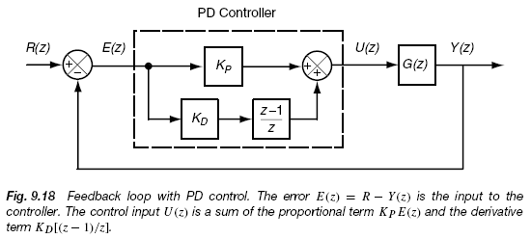

Figure :-PD CONTROL ACTION

# CHAPTER 4

## 4.1 RESULT

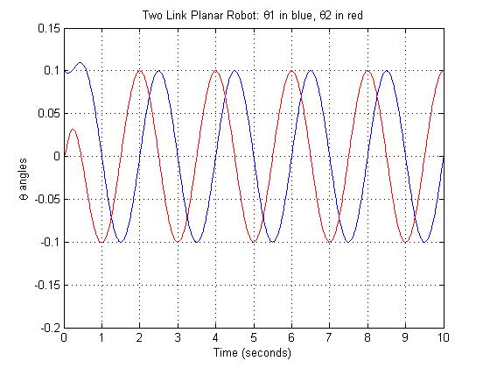

Figure 7:-TWO LINK PLANAR ROBOT

**OBSERVATION:**

This graph shows θ (position) versus time. Where x-axis define time and y-axis define position in angle.

**EXPLANATION:**

In this graph there are two exact sinusoidal path for $θ_{1}and θ_{2}$. So that the working of controller is fine.

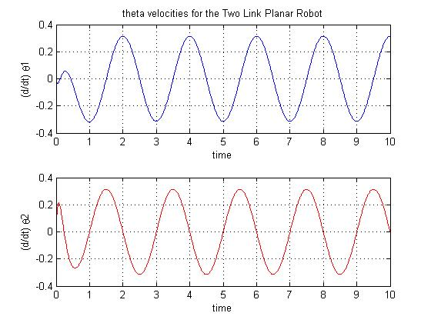

Figure 8:-VELOCITIES FOR TWO LINK PLANAR ROBOT

**OBSERVATION:**

This graph shows angular velocity versus time. Where x-axis define time and y-axis define angular velocity.

**EXPLANATION:**

In this graph there are two exact sinusoidal path in two different graph. So that the working of controller is fine.

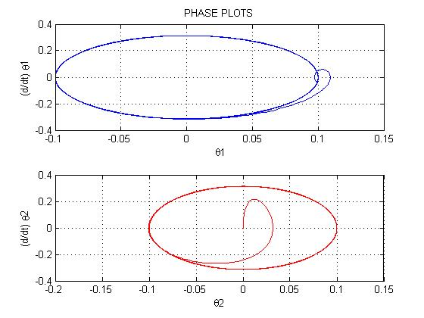

Figure 9:-PHASE PLOT

**OBSERVATION:**

This graph shows angular velocity versus position. Where x-axis define position and y-axis define angular velocity.

**EXPLANATION:**

In this graph there are two phase plot in two different graph as shown in the above figure.

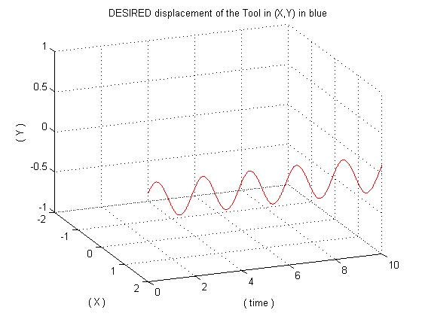

Figure 10:-DESIRED DISPLACEMENT

**OBSERVATION:**

This graph shows 3-D observation.

**EXPLANATION:**

In this graph there are a sinusoidal path which presents the desired displacement as shown in the above figure.

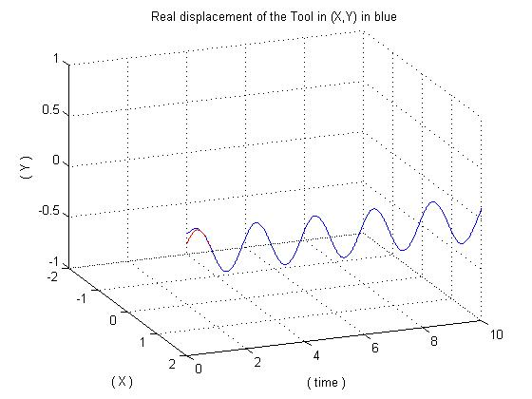

Figure 11:-REAL DISPLACEMENT

**OBSERVATION:**

This graph shows 3-d observation .

**EXPLANATION:**

In this graph there are two sinusoidal path which compare the desired displacement and real displacement as shown in the above figure.

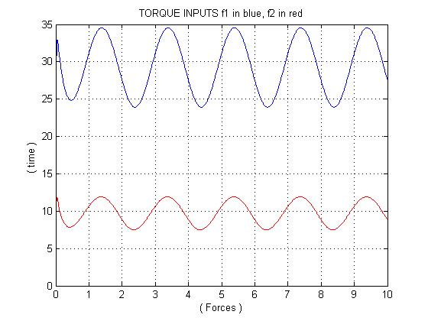

Figure 12:-TORQUE INPUTS

**OBSERVATION:**

This graph shows time versus force .where x-axis define forces and y-axis define time.

**EXPLANATION:**

In this graph there are two sinusoidal path which presents the torque inputs as shown in the above figure.

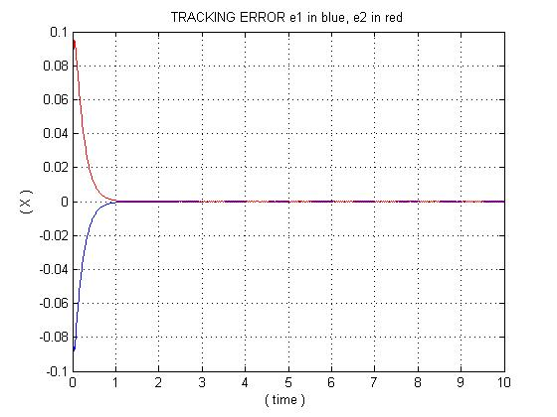

Figure 13:-TRACKING ERROR

**OBSERVATION:**

This graph shows tracking error.

**EXPLANATION:**

In this graph at the beginning when we give input to the controller the error will be maximum but after some time it decreases and reaches at zero point.

# CHAPTER 5

## 5.1 ADVANTAGES OF ROBOTIC MANIPULATOR

The major advantages :

* Ability to do straight line insertions into furnaces.
* Easy computation and programming.
* Most rigid structure for given length.

## 5.2 DISADVANTAGES OF ROBOTIC MANIPULATOR

* Requires large operating volume.
* Exposed guiding surfaces require covering in corrosive or dusty environments.
* Can only manipulate the objects in front of it.
* Axes of robot are hard to seal.

# CHAPTER 6

## FUTURE WORK

* To develop the path following controller by using Sliding mode technique.
* To verify the results by observing performances of the two link manipulator by the application of intelligent controllers.
* To study the efficacy of the controller to be developed, the simulations are to be carried out with the help of MATLAB.

# CHAPTER 7

## CONCLUSIONS

The Literature Survey on the two link manipulator has been completed.

By motivating for doing work on the trajectory tracking of Two Link Robotics Manipulator,We have developed the PD and PID controller for controlling the motion of Two Link Robotics Manipulator. The PD and PID controllers are developed and are applied on the plant. To verify the efficacy of the developed controller, the numerical simulations are carried out. The results are observed and analysed, from the results it has been surely that the controller is able to provide the exact controlling torque to the arms of the Two Link Robotics Manipulator. So that the arms are able to follow the desired trajectory.

## REFERENCES

1. J. Shah, S. S. Rattan, and B. C. Nakra. "Dynamic analysis of two link robot manipulator for control design using computed torque control*."International Journal of Research in Computer Applications and Robotics,* vol. 3, issue.1, pp., 52-59, January 2015.
2. R. Sharma, P. Gaur, and A.P Mittal, “Performance analysis of two-degree of freedom fractional order PID controllers for robotic manipulator with payload,” *ISA transactions*, vol. 58, pp.279-291, 2015.
3. S. Suklabaidya, K. Lochan, and B.K. Roy, “Control of rotational base single link flexible manipulator using different SMC techniques for variable payloads,” in *IEEE International Conference on Energy, Power and Environment: Towards Sustainable Growth (ICEPE),* pp. 1-6,June 2015*.*
4. F. L. Lewis, D. M. Dawson, and C. T. Abdallah, Robot Manipulator Control Theory and Practice, 2nd Ed., Marcel Dekker, Inc. New York, Basel, 2004.
5. BK Sahu, B Subudhi, “Adaptive Tracking Control of an Autonomous Underwater Vehicle,” *Int. Journal of Automation and Computing*, vol. 11, no. 3, pp.299-307, 2014.
6. T. Mansour, A. Konno and M. Uchiyama, Modified PID Control of a Single- Link flexible Robot, *Advanced Robotics*, 22(4), 2008, 433-449.
7. Ming-Tzu Ho and Yi-Wei Tu , PID controller for flexible link manipulator, *Proceedings of the 44th IEEE Conference on Decision and Control, and the European Control Conference*, 2005, 6841-6846.
8. Khatib O., "*A unified Approach for Motion and Force Control of Robotic Manipulators: The Operational Space Formulation*", IEEE Journal of Robotics and Automation, February 1987.
9. Sciavicco, L., and Siciliano, B., "*Modeling and Control of Robot Manipulators*"-2"'* Edition, McGraw-Hill, 1996.
10. De Wit, C.C, Siciliano, B., Bastin B., "*Theory of Robot Control*", Springer-Verlag, London, 1996.